STUDENT LEADERSHIP FOR CAREER PATHS

Agriculture

Agricultural Business
- Agricultural Mechanics
- Animal Science
- Forestry & Natural Resources
- Ornamental Horticulture
- Plant & Soil Science
- Agriscience
FFA – Future Farmers of America www.calaged.org Contact: Josiah Mayfield
CA Department of Education 1430 N Street, Suite 4503
Sacramento, CA 95814
916-319-0486
JMayfield@cde.ca.gov

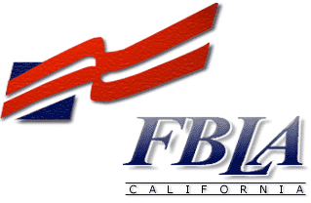Business

Business & Finance
- Business Management
- Computer Science & Information Technology
FBLA – Future Business Leaders of America
www.cafbla.org Contact: Judith Nunez
  - Box 102 Cottonwood, CA 96022 949-551-FBLA
programcoordinator@cafbla.org

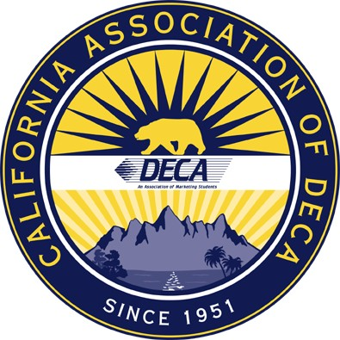Business
DECA

Marketing, Sales and Service
    - Business, Administration and Management
    - Entrepreneurship
DECA – An Association of Marketing Students www.cadeca.org
Contact: Brycen Woodley 888-605-DECA (3322)
brycen@californiadeca.org

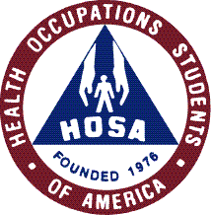Health Careers Education

Dental Services • Support Services
    - Medical Office Services • Therapeutic Services
    - Diagnostic Services • Preventative Services
    - Biotechnology Services • Nursing Services
    - Health Career Information Services
Cal-HOSA – Health Occupations Students of America
www.cal-hosa.org Contact: Cindy Beck
CA Department of Education 1430 N Street, Suite 4503
Sacramento, CA 95814
916-319-0470
CBeck@cde.ca.gov

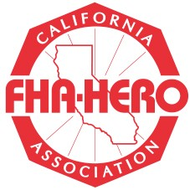Home Economics Careers & Technology

Child Development
    - Consumer Services
    - Education
    - Family and Human Services
    - Fashion Design, Manufacturing & Merchandising
    - Food Science, Dietetics & Nutrition
    - Food Service, Hospitality, Tourism & Recreation
    - Interior Design, Furnishings & Maintenance
California Association FHA- HERO
www.hect.org/fhahero Contact: Janice DeBenedetti CA Department of Education 1430 N Street, Suite 4503
Sacramento, CA 95814
916-319-0890
JDebened@cde.ca.gov

Career Technical Education

Architecture & Construction
    - Arts, A/V Technology & Communication
    - Engineering Information Technology
    - Law, Public Safety
    - Leadership
    - Manufacturing
- Transportation, Distribution & Logistics
SkillsUSA California www.skillsusaca.org Contact: Dara Dubois
CA Department of Education 1430 N Street, Suite 4503
Sacramento, CA 95814
(916) 445-7754
DDubois@cde.ca.gov

Rev. 08/28/08

