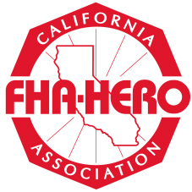
FHA-HERO: The California Affiliate of FCCLA
Region 6 Spring Leadership Meeting
February 7, 2015
Merced High FHA-HERO Chapter

FHA-HERO: The California Affiliate of FCCLA regional competition was held at Sierra High School in Manteca, California on Saturday February 7, 2015. Merced High School Chapter had great success
- Teaching Careers First Place - Jenny Lopez
- Fashion Design First Place - Yovanny Garcia and Third Place - Tahlyssa Lucero
- Interior Design Frist Place - Alyssa Brooks
- Job Application and Interview - First Place Ashley Vang
- Culinary Arts Display, Decorated Wedding Cake First Place - Jasinda Kelley and Second Place Baylee Krumm
- Commercial Foods Preparation, First Place - Team #1 Mark Stanley, Denay Burks and Joshua Anderson and Second Place - Team #2 Jesus Acevedo, Taylor Klein and Gabriel Abarca
- Menu Planning and Table Display Fifth Place - Sabrina Berger

FHA-HERO: The California Affiliate of FCCLA our State Secretary Estefany Tapia was a guest speaker.

FHA-HERO State Leadership Meeting and Competitive Recognition Events will be April 25-28, 2015 in Fresno, California.
